Jack Singley TSTEM
Irving ISD
TSTEM Leadership Meeting - https://us04web.zoom.us/j/2367505029
3.25.2020

8:30: Check In

Benchmark 1 - School Design - PD Plan, Leadership Meeting Agenda
https://lead4ward.com/school-at-home/?fbclid=IwAR1i9E7G5yDb7QXfJ-_XAVch9s7hGDKKb5kq0CL_pp-w5tj25pkbldAE4-0
- Schedule set by district with periods, PLC and work time for teachers

Benchmark 2 - Target Population - enrollment & recruitment updates
- Fish Camp in August
- Parent/Student Meeting in August

Benchmark 3 - Strategic Alliances - DCCCD online
- Starts on 3/30

9:30 Benchmark 4 - Curriculum, Instruction and Assessment - systems for monitoring work completion, grades, tutoring needs
- Nepris is an option

Benchmark 5 - Work-Based Learning
- Meeting tomorrow, 3/26, to discuss

Benchmark 6 - Student Support

Next Steps | Provided Resource
Register for Summit | https://www.edtx.org/get-involved/events/ccrsm-2020-leadership-summit
ECHS report review | https://www.air.org/sites/default/files/downloads/report/Early-College-Continued-Success-Longer-Term-Impact-of-ECHS-September-2019-rev.pdf
Dates for Future Meetings

Print Name | Title | Roles | Signature
Lisa Casto | Coach | Coach | 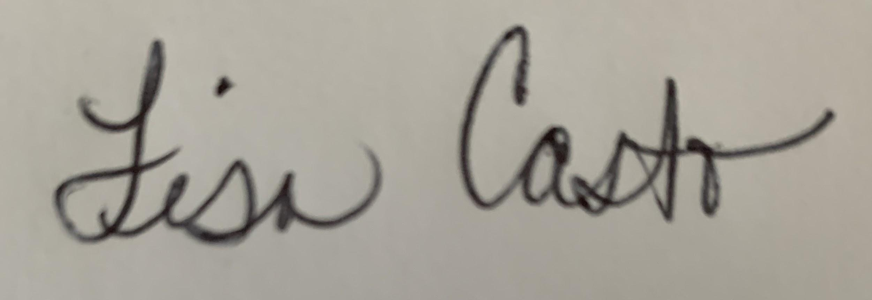
Jenny Anderson | Assistant Principal | Campus Admin | 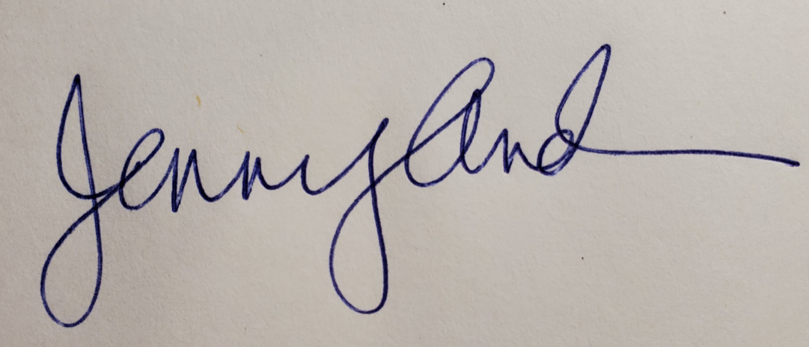
Katie Crone | Academic Specialist | Academic Specialist/STEM Coordinator
Rachel Lomax | Lead Counselor | Counselor | 